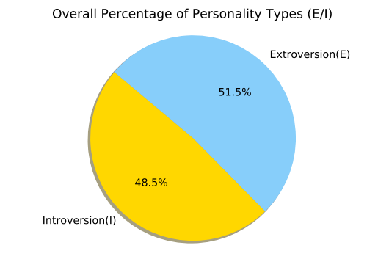 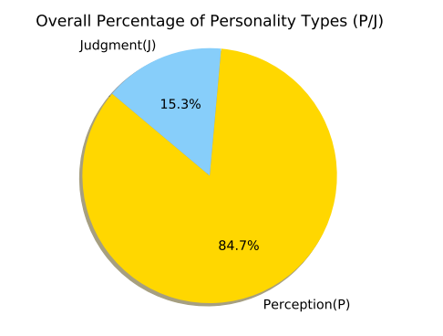

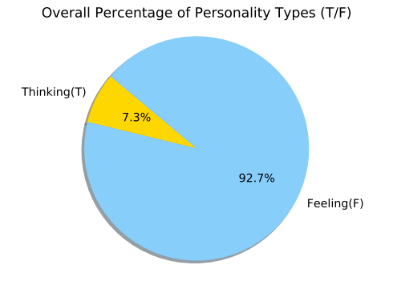 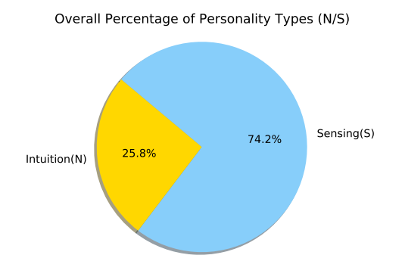

Fig. 1.1 The pie charts represent the overall percentage of reviewers’ personalities leaving comments on the sample Yelp dataset.

After analysing over 82,600 reviews on 56 businesses in Las Vegas city, we found that the personality distribution of the Yelp Reviews sample, showed that the personality types F, S and P are the most common personalities to comment and rate a business. In contrast, T, N and J are less likely to participate in ratings, while I and E personalities equally post reviews on businesses in the sample dataset.

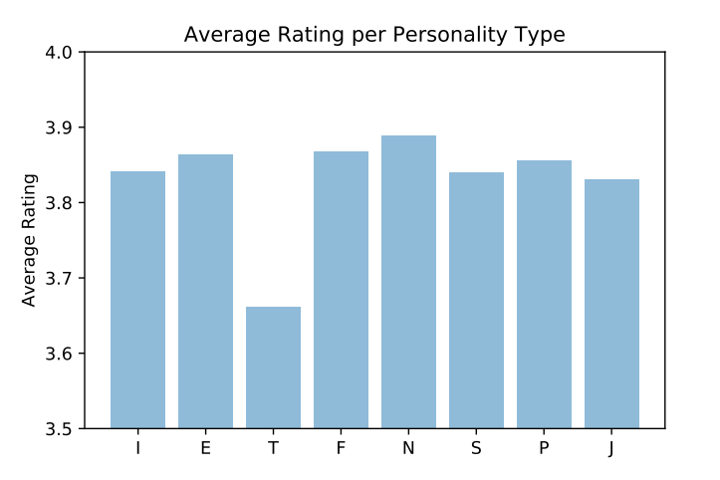

Fig. 1.2 This bar chart illustrates the average rating given by a personality type.

From the rating perspective, we found that the average rating given by the different personality types ranges between 3.65 to 3.9 which does not create a significant variance between the ratings of the different personalities (fig 1.2). In other words, the personality type is not a good indication on the rating that is likely to be given by the reviewer. However, the distribution of these personalities will differ from one business to another, hence, the business can make decisions based on the personality types affecting their own rating. As an example, figure (1.3) demonstrates a sample business with different personality distributions.

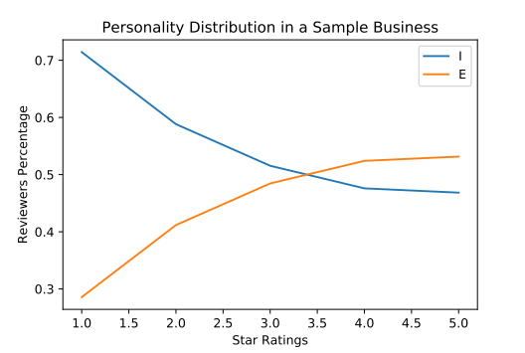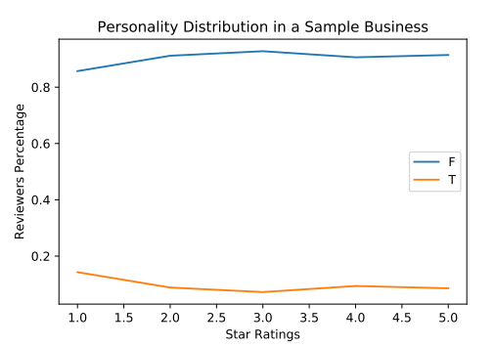

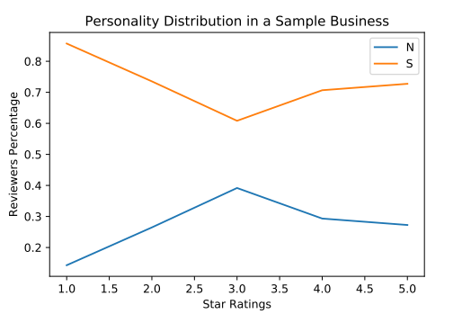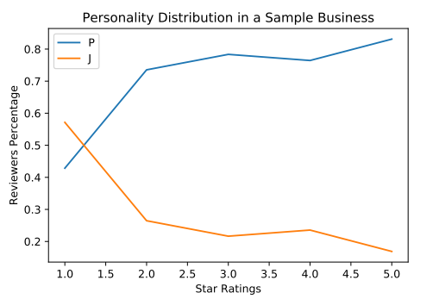

Fig1.3: The line charts show a sample business with different distribution of personalities contributing in rating the business.

The standard deviation in the number of personality types commenting on a business is listed in the below table:

|  |  |  |  |  |  |  |  |
| --- | --- | --- | --- | --- | --- | --- | --- |
| Standard deviations between personality types across sample businesses | | | | | | | |
| 0 | 508.543298 | 16 | 330.508699 | 32 | 391.250377 | 48 | 447.514724 |
| 1 | 407.101602 | 17 | 378.924041 | 33 | 504.959687 | 49 | 356.306048 |
| 2 | 623.731169 | 18 | 497.800591 | 34 | 324.731977 | 50 | 421.599336 |
| 3 | 353.033790 | 19 | 639.033422 | 35 | 311.898335 | 51 | 577.649671 |
| 4 | 403.686229 | 20 | 1310.307707 | 36 | 461.810413 | 52 | 375.684898 |
| 5 | 348.034892 | 21 | 448.352221 | 37 | 725.783321 | 53 | 288.314808 |
| 6 | 318.500505 | 22 | 291.681333 | 38 | 378.181362 | 54 | 296.874192 |
| 7 | 622.843021 | 23 | 1100.749485 | 39 | 323.829761 | 55 | 769.508563 |
| 8 | 371.867488 | 24 | 324.958459 | 40 | 336.646911 |  |  |
| 9 | 922.748534 | 25 | 472.076568 | 41 | 846.395888 |  |  |
| 10 | 305.396698 | 26 | 398.765954 | 42 | 333.276805 |  |  |
| 11 | 306.425008 | 27 | 320.862231 | 43 | 320.783861 |  |  |
| 12 | 301.528013 | 28 | 577.438432 | 44 | 392.713272 |  |  |
| 13 | 422.110006 | 29 | 330.802487 | 45 | 681.875146 |  |  |
| 14 | 442.966945 | 30 | 832.477370 | 46 | 694.363017 |  |  |
| 15 | 281.402102 | 31 | 339.110601 | 47 | 483.563262 |  |  |

Fig1.4: The table above lists the standard deviation of the business reviews counts among the different personality types in a business.